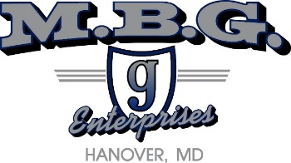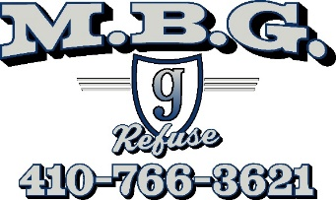

Unauthorized Riders and Drivers

MBG Enterprises Inc. & Refuse Services employees does not permit unauthorized drivers or riders in MBG Enterprises Inc. & Refuse Services employees owned vehicles.

An unauthorized rider or driver shall be defined as: Any person other than the assigned operator of the unit, or a MBG Enterprises Inc. & Refuse Services employee who is un-qualified or not listed on MBG Enterprises Inc. & Refuse Services employees ’s authorized drivers list.

Riders are permitted when they have a business relationship with MBG Enterprises Inc. & Refuse Services employees or the authorized driver of the vehicle.

Vehicle Restraints and Seat Belts

Seat belts are required to be worn by all MBG Enterprises Inc. & Refuse Services Inc. employees vehicle occupants as prescribed by Maryland state statute. It is the responsibility of the driver to ensure that before vehicle is placed in motion that all occupants are securely belted in.

Authorized car seats and booster seats will be used according to Maryland State statute in accordance with appropriate age and size of youth transported.

Any MBG Enterprises Inc. & Refuse Service Inc. Employee receiving work related injuries as a failure to abide by MBG Enterprises Inc. & Refuse Service Inc. will be reprimanded and or terminated.

Employee Name Print: _______________________________

Employee Signature: _________________________________

Date ____/___/____

