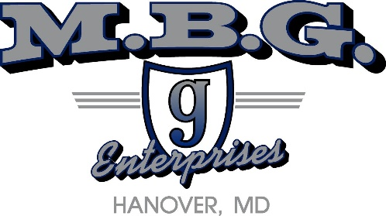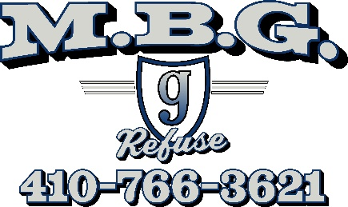

At Will Employment Acknowledgement Form

Your employment with MBG Enterprises Inc. and MBG Refuse Services is at will. This means your employment is for an indefinite period of time and it is subject to termination by you or MBG Enterprises Inc. and MBG Refuse Services with or without cause, with or without notice, and at any time. Nothing in this policy or any other policy of [employer name] shall be interpreted to be in conflict with or to eliminate or modify in any way, the at will employment status of MBG Enterprises Inc. and MBG Refuse Services.
employees.
The at will employment status of an employee of MBG Enterprises Inc. and MBG Refuse Services may be modified only in a written employment agreement with that employee who is signed by the President, or the Chairman of the Board of Directors, of MBG Enterprises Inc. and MBG Refuse Services, Mitchell Gunther Sr.
By your signature below, you acknowledge your understanding that your employment with MBG Enterprises Inc. and MBG Refuse Services, Mitchell Gunther Sr. is at will, and that nothing in this handbook is intended to constitute a contract of employment, express or implied.

_____________________________________
Employee Signature
_____________________________________
Employee Printed Name

Date ___/___/___

